4) Write a node.js program to read form data from the query string and generate a response
const http = require('http');
const url = require('url');
const querystring = require('querystring');

const server = http.createServer((req, res) => {
// Parse the URL to get the pathname and query string
const parsedUrl = url.parse(req.url);
const pathname = parsedUrl.pathname;

// Check if the request is for the form submission endpoint
if (pathname === '/submit-form' && req.method === 'GET') {
// Parse the query string into an object
const queryData = querystring.parse(parsedUrl.query);

// Set the response header
res.writeHead(200, { 'Content-Type': 'text/html' });

// Generate the response based on the query data
let responseHtml = '<h1>Form Data Received:</h1>';
if (Object.keys(queryData).length > 0) {
responseHtml += '<ul>';
for (const key in queryData) {
responseHtml += `<li><strong>${key}:</strong> ${queryData[key]}</li>`;
}
responseHtml += '</ul>';
} else {
responseHtml += '<p>No data submitted in the query string.</p>';
}

res.end(responseHtml);
} else if (pathname === '/') {
// Serve a simple HTML form
res.writeHead(200, { 'Content-Type': 'text/html' });
res.end(`
<!DOCTYPE html>
<html>
<head>
<title>Simple Form</title>
</head>
<body>
<h1>Submit Data via GET</h1>
<form action="/submit-form" method="GET">
<label for="name">Name:</label><br>
<input type="text" id="name" name="userName"><br><br>
<label for="email">Email:</label><br>
<input type="email" id="email" name="userEmail"><br><br>
<input type="submit" value="Submit">
</form>
</body>
</html>
`);
} else {
// Handle other requests (e.g., 404 Not Found)
res.writeHead(404, { 'Content-Type': 'text/plain' });
res.end('404 Not Found');
}
});

const PORT = 3000;
server.listen(PORT, () => {
console.log(`Server running at http://localhost:${PORT}/`);
});
OUTPUT
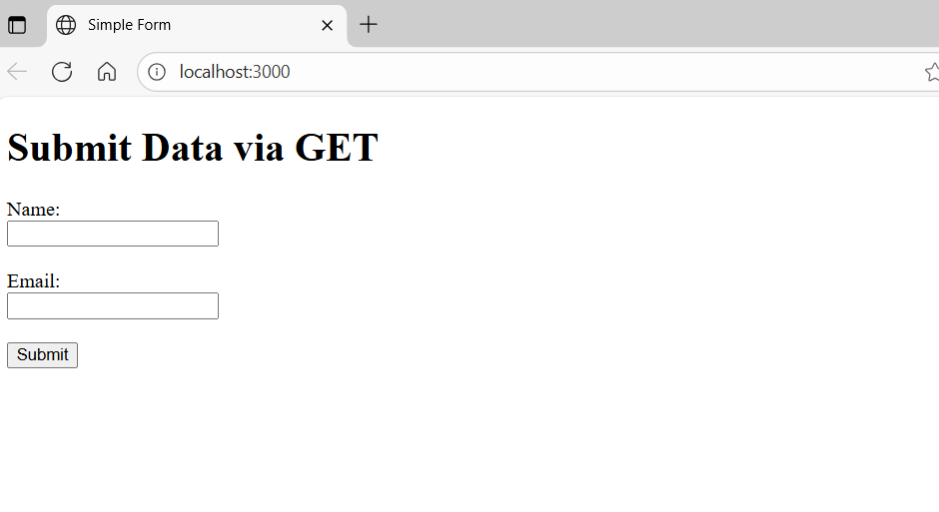
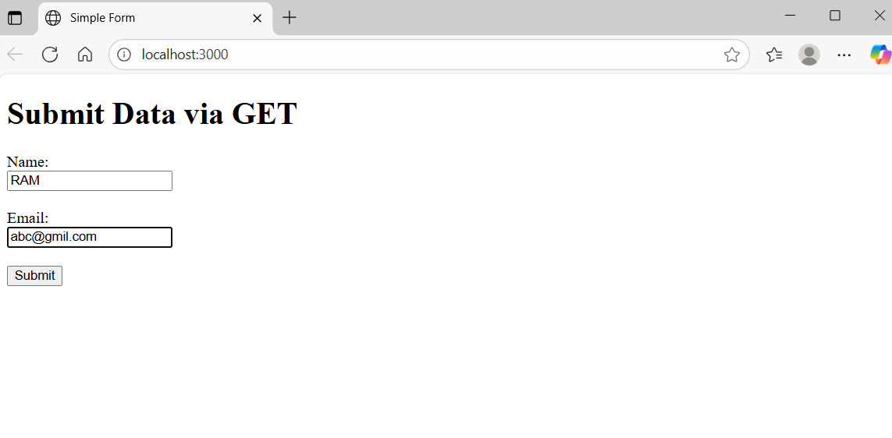
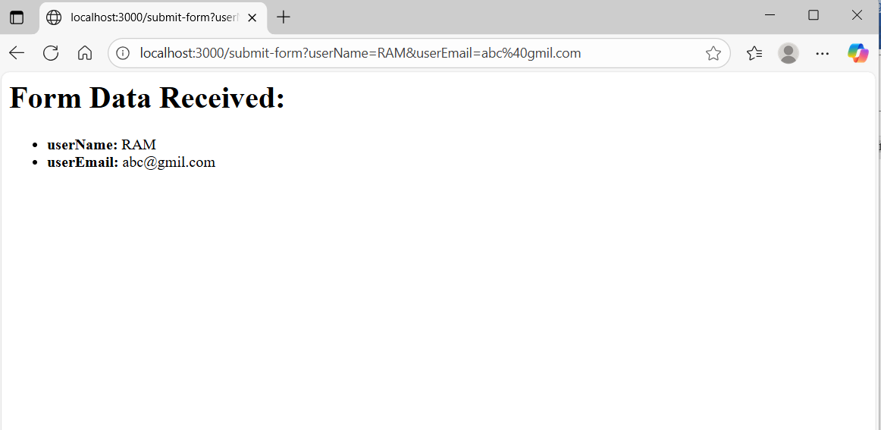

- http and url Modules:
The http module is used to create the server, and the url module is used to parse the incoming request URL. The querystring module helps in parsing the query string into a JavaScript object.
- Server Creation:
http.createServer() creates an HTTP server instance.
- Request Handling:
The callback function passed to createServer is executed for every incoming request.
- URL Parsing:
url.parse(req.url) parses the request URL into an object containing various components, including pathname (the path part of the URL) and query (the raw query string).
- Query String Parsing:
querystring.parse(parsedUrl.query) converts the raw query string (e.g., "userName=John&userEmail=john@example.com") into a JavaScript object (e.g., { userName: 'John', userEmail: 'john@example.com' }).
- Conditional Response:
The code checks the pathname and req.method to determine if it's a GET request to /submit-form.
- Generating Response:
If it's a form submission, the program iterates through the queryData object and constructs an HTML response displaying the received data.
- Serving the Form:
If the request is for the root path (/), a simple HTML form is served, which, when submitted, will send data via a GET request to /submit-form.

- Server Listening:
server.listen(PORT, ...) starts the server and makes it listen for incoming requests on the specified port.
VivaQuestions
- What is the purpose of the http module in Node.js?
- What does the url.parse() function do in this program?
- How is form data sent to the server using the GET method?
- What is the role of the querystring module in the program?
- Why do we check pathname === '/submit-form' and req.method === 'GET'?
- What is a query string? Give an example.
- Explain how the server generates an HTML response with the submitted form data.
- What happens when the user visits only the root path (/) in the browser?
- What will the server respond with if no data is submitted in the query string?
- What will happen if a user accesses a URL that does not match any defined route (e.g., /about)?

